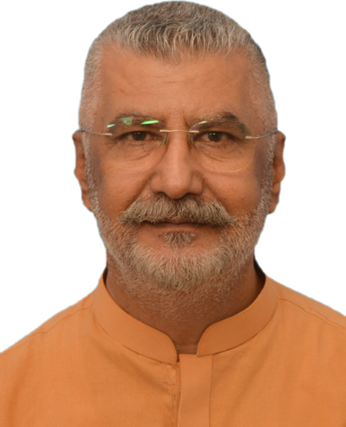
MUHAMMAD NADEEM ASLAM

Profession: Civil Engineer

Date of Birth: 19th April 1966
Marital Status: Married
Nationality: Pakistan
NIC No: 6110117718017
Language Skills: English, Urdu, Pushto, Punjabi.
Experience: 29 years
Permanent Address: House # 1132, Street # 41, G -10/4, Islamabad.
Cell: 0300-9559759.
E-mail: n4nadeem_s@yahoo.com.
Skype: nadeem.aslam1966

OBJECTIVES:

To work in a competitive environment where I can exercise my Pilling work bilities and expertise in an efficient way to enhance my skills to become a highly professional, leading Civil Engineer.

SPECIALLY WORKED IN THE FOLLOWING AREAS

- QA/QC
- Infrastructure
- Housing society infrastructure
- Manage& review Contractor submitted EOT Claims
- Facilities Management
- Project Management
- Administration Management
- Cost Control Management
- Tendering Management
- Variation Orders preparation &Verification
- Project Planning
- Preparation of contract Documents
- Verification of IPC’S
- Building Works (Villas & High-rise)
- Roads & Bridges
- Pilling work
- Earth Work

EMPLOYMENT RECORD

October 11,2021 To Date
Employer Square Nine International
Job Title Projects Director (Devp & Const)

Key Responsibilities

All Hotel buildings ( Ramada Plaza, Best Western, The Avenue ) and other commercial buildings construction supervision under my Responsibility
From scratch till finished.

EMPLOYMENT RECORD

June, 2019 27 September 2021
Employer: SIAL (Sialkot international Airport)
Job Title: Project Director

All Hotel buildings ( Ramada Plaza, Best Western, The Avenue ) and other commercial buildings construction supervision under my Responsibility
From scratch till finished.

lopment works.

November, 2007 May, 2019
Employer: Bahria Town (Pvt) Ltd.
Job Title: Chief Resident Engineer.

Key Responsibilities

- Responsible for QA/QC related works of Development/Infrastructure(Roads, Sewerage, Water Supply, Drainage, Electricity etc) and Building Construction (School, Mosque, Hospital Storied Apartments, Trafalger Square, Parks,Zoo etc) at Bahria Enclave Project Islamabad.
- Supervising Concrete Batching Plants (Ready Mix Conc).
- Preparation of Tender Documents.
- Supervising the team of Quantity Surveyors for the preparation of IPC’s, Claims, and Variation Orders etc.
- Preparation of Contracts.
- Head Building Control Department to control Bye Laws of Bahria Town (Pvt)Ltd for Residential buildings and Commercial Buildings.

November 2004 Oct,2007
Employer Mott MacDonald Pvt Ltd. (The UK based Co)
Job Title: Resident Engineer

Key Responsibilities:
- Resident Engineer/Project Manager / Manager QA/QC / Project Coordinator for two projects of Higher Education
- Commission and One project of Army Burn hall college Abbottabad.
In charge of QA/ QC for above mentioned projects.
- Preparation of prequalification documentation and prequalification’s of Sub-Cons and Consultants.
- Preparation of contract documents for contractors and consultants.
- Responsible for overall project management and coordination.
- Working as an office Engineer in Regional office Islamabad.
- Nominated as coordinator for QES (Quality Environment & safety) of all on going projects in Pakistan.
- Responsible for all Water & sanitation projects with the company in North.
- Management:
- To manage all the problems at the site with the coordination of contractor. My key responsibilities are to deal With the main contractors and I have also to deal with the local subcontractor of these main contractors.

December 2002 To November 2004.
Employer: NESPAK (Pvt) Ltd.
Job Title: Asstt Resident Engineer.

- Detailed Task Working on the following Projects.
- NUST University Road Project in Islamabad, responsible for earthworks in Cutting / Filling areas, Structures Works consisting of all Building activities from foundation till finishing etc.
- Dualization of Al-AQR to Khatmat Malah Road (22 KM) in Sultanate of Oman. Responsible for all Earthworks, Structure works and Asphalt work consisting of asphalt wearing course etc.
- Al-LAKBI to SAWQRA Coastal Road in Sultanate of Oman and responsible for placement of sub-base and base course.
- Rustaq to Miskin Road Project in Sultanate of Oman. Responsible for supervision of 04 #Bridges.
- RYK- TMP Section N-5 Dual Carriage way, responsible for Checking of IPC’s Preparation of Bar Bending Schedule of Bridges/Culverts, Preparation of Rate Analysis, Estimation, Variation Order etc.
- PRSP Road Projects of Punjab Highways at Lawrence College Road Muree. Responsible for checking the compaction of laid embankment layers by F.D.T,
- and other quality tests consistingof Sieve Analysis, CBR etc

February 1994 To March 1998.
Employer: NESPAK (Pvt) Ltd.
Job Title: Site Inspector / Material Inspector.

Detailed Tasks Worked on Faizabad Inter change Project Islamabad.
Supervision of earthwork, Preparation of Sub-Grade, Sub-Base, Base Course.
Supervised Concrete Structures (Abutments, Piers, Girders, Transoms, Piles, and Deck Slabs) of 04 # Bridges.
F.D.T, Gradation, CBR, Proctor Test, Asphalt Test etc.

September 1991 To January 1994
Employer: NESPAK (Pvt) Ltd.
Job Title: Site Inspector/ Material Inspector.

Detailed Tasks Booni Road Project in Chitral.
Supervised Earthwork (Cutting/Filling), responsible for Structures Works consisting of all
Building activities from foundation till finishing etc.

October 1990 To October 1991
Employer: M/S Shah Zaman (Pvt) Ltd.
Job Title: Sub-Engineer

Detailed Tasks Worked on Mardan SCARP Project.

Responsible for boring of various Tube Wells in District Mardan.

ACADEMIC HISTORY

UNIVERSITY / COLLEGE DEGREE

- UET AjK B.Sc Civil Engg.
- GCT Peshawar DAE Civil Engg.
3. Serhad University MBA(Proj Mng)
4. AIOU Islamabad MSc Env Dsg in process

SKILL

1. Microsoft Project
2. Primavera P3
3. MS Office

